**Using Search in Signal Safe**

1. **Click** on the **Search** in the **Menu** **Bar**

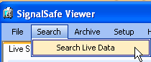

1. Then **Select** the **Search Live Data**
2. 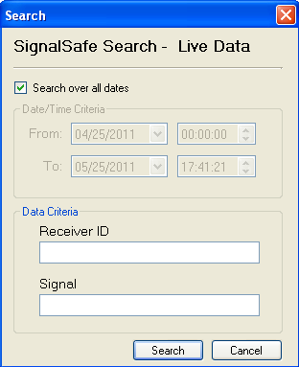The **Search** Window will pop up
3. 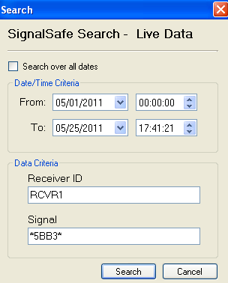**Fill** **in** the **parameters** to search on

**Example**:

**Dates**: 05/01/2011 to 05/25/2011

**Receiver** **ID**: RCVR1

**Signal**: *5BB3*

*(****Wildcard*** *‘****\*****’ means anything before and after the data that’s being looked for)*

**Click** on **Search** Button

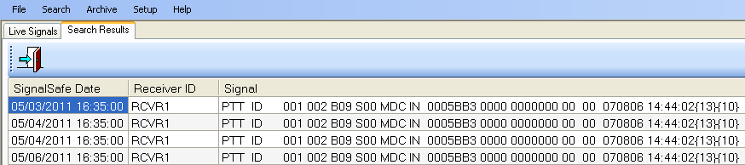

1. The **search** **results** will open in a **new** **tab**

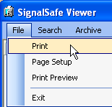

1. **Select** File and **Print** from the **File** **menu** to **print** the results.
2. Once completed **Click** on **Exit** door and search tab will close