**Replication Pre-Requisites: A How to Guide**

1. **How to create a Local Windows User**

Click on Start > Control Panel > Administrative Tools > Computer Management

In the System Tools area expand Local Users and Groups

Right click on Users and select New User…

User name: PHXREP

Full name: PHX Replication User

Description: PHX Replication User

Password: F!1GHT!2

Confirm Password: F!1GHT!2

Uncheck ‘User must change password at next logon’

Check User cannot change password

Check Password never expires

Click Create button, then the Close button, the ‘new’ User will display in the list

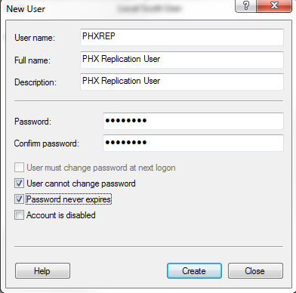

Right click on the new user name and choose Properties

In the PHXREP Properties window select the Member Of tab, click Add…

In the Select Groups click Advanced…

In the Select Groups window click Find Now

Highlight Administrators, then click OK

Click OK to close the Select Groups window

Click Apply then OK, to assign the new user to the Administrators Group

Close the Computer Management window.

1. **Create a SQL Server Login**

Click on Start > All Programs > Microsoft SQL Server 2014 > SQL Server 2014 Management Studio

The Connect to Server window will display

Server Type: Database Engine

Server name: PHXRACKSRV

Authentication: SQL Server Authentication

Login: sa

Password: F!1GHT!2 click Connect

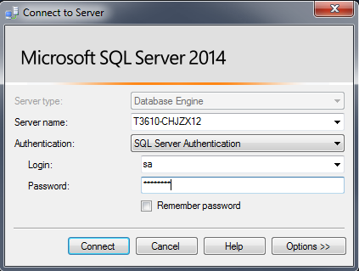

Expand the node PHXRACKSRV > Security > Logins

Right click on Logins and choose New Login..., the Login- New window displays

Login name: PHXREP

SQL Server Authentication

Password: F!1GHT!2

Confirm Password: F!1GHT!2

Uncheck ‘Enforce password policy’

Uncheck ‘Enforce password expiration’

Uncheck ‘User must change password at next login’

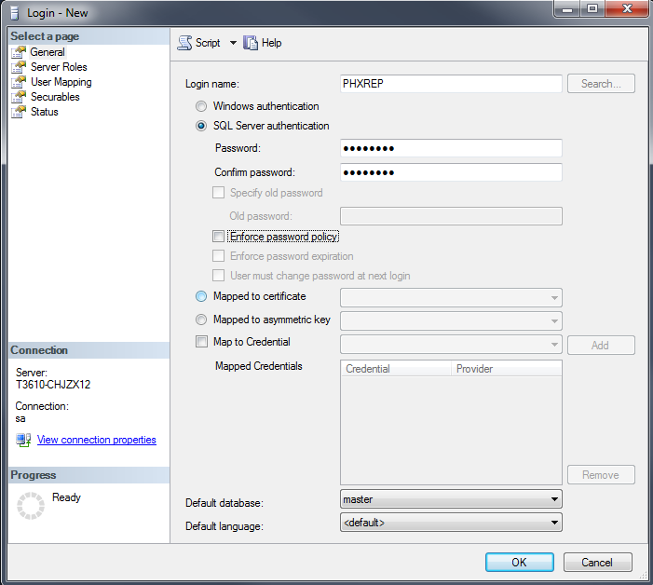

In the Select a page area at the top left select Server Roles

Select the ‘sysadmin’ checkbox

Click OK to close the Login – New window.

Close the Microsoft SQL Server Management Studio window

1. **Enable SQL Configuration**

Click on Start > All Programs > Microsoft SQL Server 2014 > Configuration Tools > SQL Server 2014

Configuration Manager

Expand SQL Native Client 11.0 Configuration(32 bit)

Select Client Protocols

on the right Shared Memory, TCP/IP , Named Pipes, VIA should

all be enabled. If not, right click on the line and choose Enabled

Expand SQL Server Network Configuration

Select Protocols for MSSQLSERVER

On the right Shared Memory, Named Pipes and TCP/IP should all be enabled.

If not, right click on the line and choose Enabled

Expand SQL Native Client 11.0 Configuration

Select Client Protocols

on the right Shared Memory, TCP/IP , Named Pipes, VIA should

all be enabled. If not, right click on the line and choose Enabled

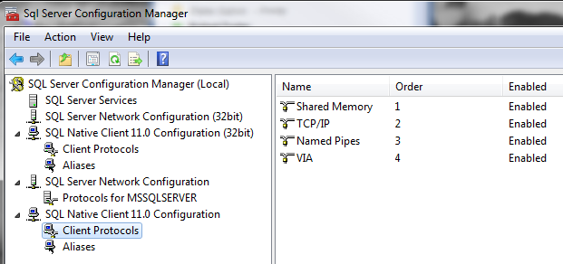

1. **Windows Firewall Exception of SQL Server**

Click on Start > Control Panel > Windows Firewall

Click Advanced Setting on the left

Click Inbound Rules at the top left

Click New Rule… at the top right, the New Inbound Rule Wizard opens

Select the Port radio button, click Next

Ensure the TCP radio button is selected, in the Specific Local Ports field enter 1433, click Next

Ensure the Allow the connection radio button is selected and click Next

Ensure that Domain, Private & Public checkboxes are selected, click Next

Give this new inbound rule the following name SQL Server Port

Click Finish

1. **Create a Shared Folder**

Click on Start > Computer > double click on Local Disk (C:) > select New Folder at the top

Rename the new folder: REP_FOLDER

Right Click on REP_FOLDER and choose Properties

Select the Sharing tab, click the Share… button

The File Sharing window will open,

Click in the [empty] dropdown are and select Find People

[Share Folder]

Within the Select Users or Groups window click Advanced…, click on Find Now

Scroll through the list of Users and Groups to locate the PHXREP user, click OK

Click OK to close the Select Users or Groups window

Select the PHX Replication User line and change the Permission Level to Read\Write

then click Share, then Done

Select the Security tab, highlight PHX Replication User and click Edit…

The Permissions for REP_FOLDER window opens

Highlight PHX Replication User and click the checkbox associated with Full Control / Allow

Click Apply, then OK

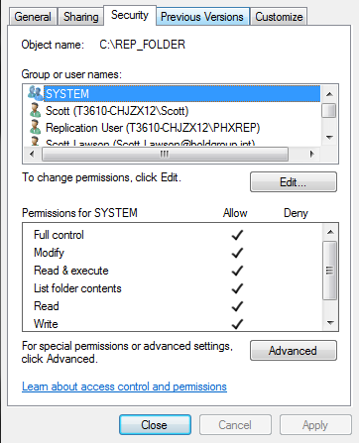

Click Close to close the REP_FOLDER Properties window

1. **Install and Configure DBManager2**

Copy the DBManager.exe to the root of the Phoenix folder

Create a Desktop shortcut for DBManager

Click on the DBManager icon to launch the application (it will take a few seconds for it to open)

Click on File > New, the DBManager window opens

Database Manager opens with the Configure > Databases page selected

Database System Name: Phoenix_Rep

Database System Type: Other

Databases

Server Name: select the name of the primary Phoenix DB server from the list

Use Windows Authentication: uncheck this box

Login: PHXREP

Password: F!1GHT!2

Database: select the ‘Phoenix’ database option from the list

Click on the Tab key – this will create a new line so you can enter the secondary server, use the same setting as above, except for the server name.

When both servers have been entered click on File > Save

Save the configuration file at the root of the Phoenix folder as PHX_DB_Config.dbsystem

Click on Replication

Replication Agent Windows Account: PHXREP

Replication Agent Windows Password: F!1GHT!2

Working Directory: \\PHXRACKSRV\REP_FOLDER

Manitou Customer Activity: Uncheck [All]

Distributor Location: check Local Distributor

Click File > Save

Click on Manage Replication

You will get a graphic displaying an icon for each server, under each server is a “Make Primary” link. Click this link for the server that is the ‘active’ / primary / Publisher database. The other servers will be configured as ‘backup’ / secondary / Subscription databases. The DBManager utility will take over from there.