116791

How to Mange Users in Phoenix
The following document will go over the steps needed to manage the users within Phoenix. These steps can be used in all versions of Phoenix.

OVERVIEW
Every user of Phoenix must have a valid User ID on file in the database to log into Phoenix. To ensure a higher level of security the Phoenix administrator should establish the following guidelines. There are four default users that should not be changed as well.

A. User Guidelines
- Assign each User an individual ID for authentication purposes.
- Assign each User a unique password
- Configure Authorization Levels to allow access on an as-needed basis.
- Set Effective Date/Time and Expiration Date/Time appropriately for each User.
- Require Users to change Passwords in a predefined cycle (default is 90 days).

B. Default Users
Phoenix has 4 default users: DO NOT DELETE THEM!

- User ID -1 is a System Marker Record, DO NOT DELETE OR CHANGE in any way.
- User ID 1 logout prevents the last person logged into Alarm Processing from logging out without a password.
- User ID 998 phoenix administrative user log in. This login SHOULD NOT be used as a regular login for operators; can be used to enter additional users.
- User ID 999 administrator this is a secondary administrative user in case the phoenix user gets deleted or changed.

- Creating a User
- Open Data Entry.
- On the Tables menu, Click on User
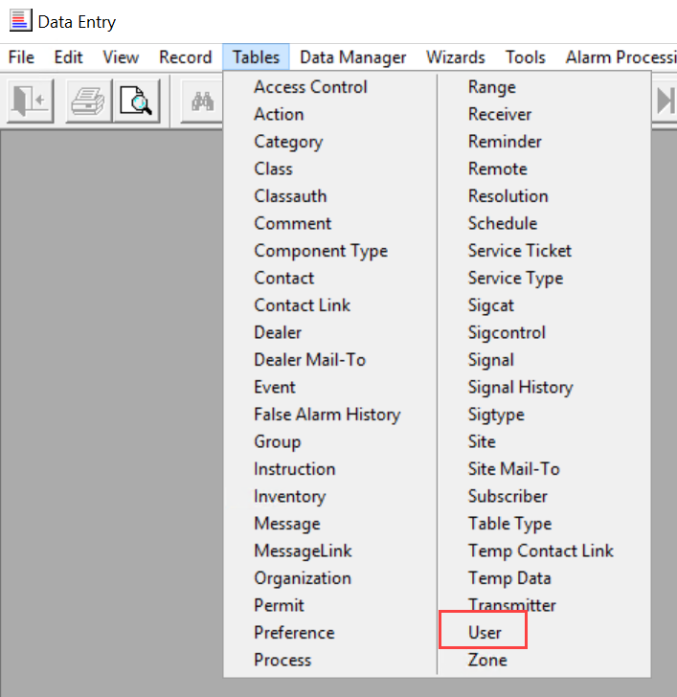
- User Form will open
Helpful Hint - to determine which numbers have already been used, click the Clear tool (if you have entered any values) click the Query tool (Binoculars) and then the List View tool, and look in the User Id column. Pick a number that is not listed up to 999.
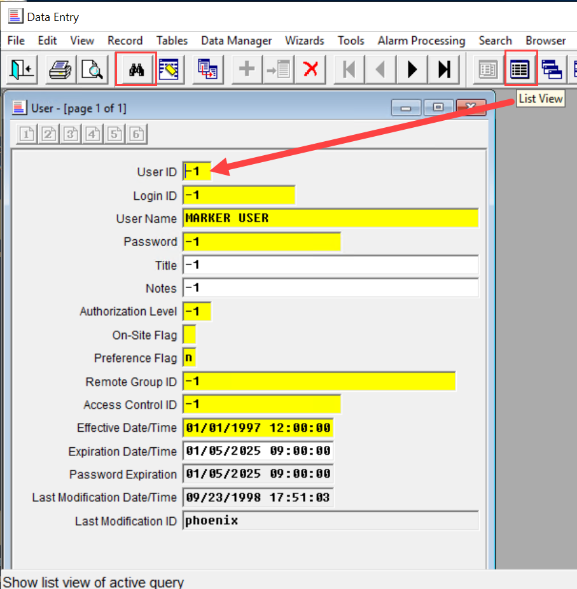
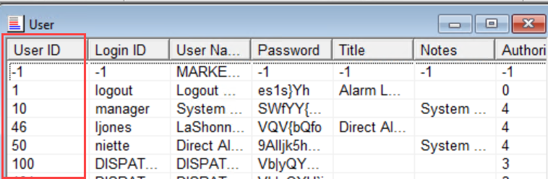

- User Record Blank Form:
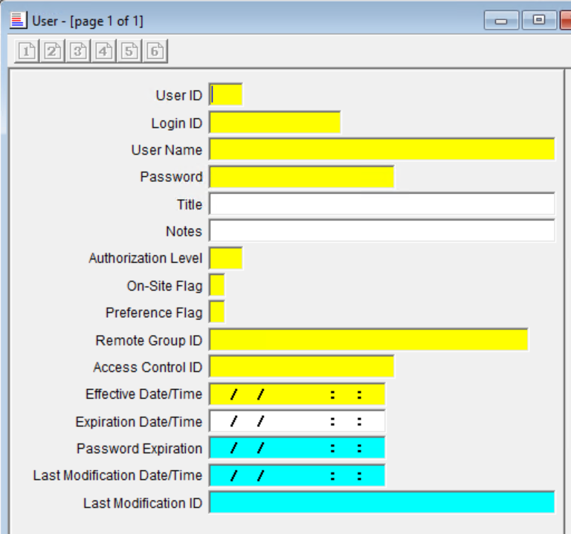
- User ID field, Enter a unique number to identify the User.
- Login ID field, Enter a short form of the User’s name (no spaces) for use during the Login process. This field must also be unique.
- User Name field, Enter the User’s full name.
- Password field, Enter the word “password”. This is the only acceptable password for a new user or resetting the password.
- The first time the User logs in to any app, Phoenix prompts for a password change. The Password is encrypted when the record is saved. Passwords must be 6 alphanumeric characters long and expire every 90 days.
- When a user forgets their Password, change it to “password” in the appropriate record in the User Table, and have them proceed as if they were a new User.
- Title field, Enter the user’s job, if desired.
- Notes field, Enter any comment or remark concerning the User or the Record.
- Authorization Level field, Enter one of the following Level numbers to indicate the application and functions to which the User has access (there are no restrictions on Browser, since a Login ID and Password are not required):
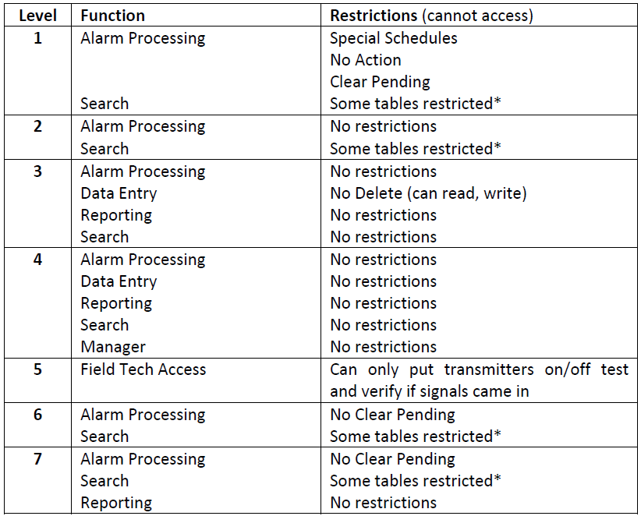

* Users with this Access Level cannot access the following tables:
Access Control Message Sigcat
Category Preference Sigcontrol
Class Process Sigtypes
Classauth Remote Table Types
Component Types Resolution User
Group Service Type

- If none of the levels meet what is needed, a new Authorization Level can be added to fit that need; See “Security” in the System Users’ Guide.

- On-Site Flag, In the On-Site field choose Y if the User is located at the monitoring center; choose N if at a remote location. Remote Users, by default, are not able to access Alarm Processing.
- Preference flag field, Choose N if the user can process any alarm in Alarm Processing. Choose E to define preferred Events. To make Preferences work you must also set up records in the Preferences table; “Setting up Preferences”.
Helpful Hint – Preferences are most helpful for monitoring centers with at least eight operators working at a time.
- Remote Group ID field
- Enter -1 for most Users. For remote Users accessing the monitoring center’s database through Phoenix Remote Data Entry Add-on Module, enter the appropriate Remote Group ID; see the “Remote Data Entry User Guide”
- Access Control ID field, Enter -1 for most Users. For a field technician who will use Field Tech Access, enter the appropriate Access Control ID, see the “Field Tech Access Users’ Guide”.
- Effective Date/Time field, Enter the date and times on which the User may begin logging in to Phoenix.
- Expiration Date/Time field, Enter the date and time on which the User may no longer login to Phoenix. Leave it blank if unknown.
- Password expiration field, Phoenix writes the date when the User’s Password will expire; this field is read-only and cannot be edited.
- Last Modification Date/Time field, Phoenix enters the date and time the record was last modified; this field is read-only and cannot be edited.
- Last Modification ID field, Phoenix enters the Login ID of the user who last modified the record; this field is read-only and cannot be edited.
- Click on the ADD tool; Phoenix writes the record to the User table. To change the record at any time, see “Updating Records”.

- To Update (change) data in a user record
- On the Table Menu, choose the User table.
- Locate the applicable user record to change.
- Correct the appropriate information in the record.
- Click the Update tool to write the changed record to the database.
Update (Record menu) Ctrl + u

- Delete a User Record
- On the Tables menu, choose the User table.
- Locate the applicable user record to remove.
- Click on the Delete tool to permanently remove the record from the database.
Delete (Record Menu) Ctrl + d

Helpful Hint – if you receive an error “Database Request Failed” you are likely trying to delete a record that is referenced by another table(s). For example, if a transmitter has two zone records and you try to delete the transmitter record before deleting the zone records, Phoenix will display this error message and not delete the transmitter record.

