116980

How to Make Hierarchy Changes in Phoenix Data Entry
The Hierarchy Change Tool can make data changes easier to rename, copy, or delete multiple hierarchy records at the same time.
For example: Need to change a Transmitter ID use this command to change all records in the database that contain that ID.

This feature can also be used as a template.
For example: Can set up a generic transmitter with common data for a dealer and use Copy to create specific transmitters under the same Dealer and then change the other data as needed.

Overview
The steps below assume the user doing the steps has the correct permissions to complete them.

- It is recommended to back up your data prior to making any kind of changes to the data using this tool.

Steps:
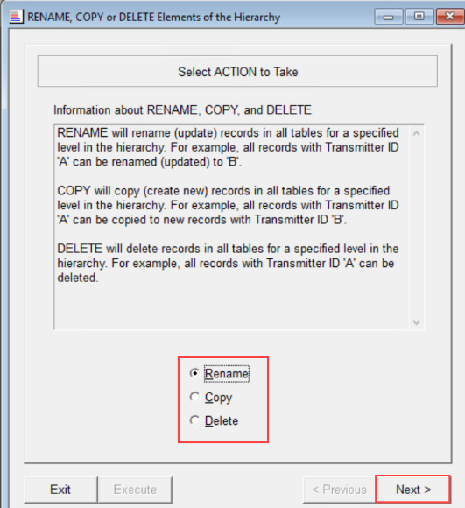
Open The Hierarchy Change Tool by clicking on Tools – Hierarchy Changes from the dropdown menu. There are three options that can be used: Rename, Copy and Delete.

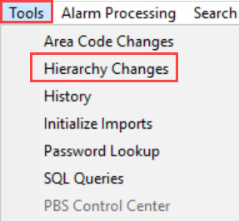

- Rename
Will rename (update) records in all tables for a specified level in the hierarchy. For example, all records with Transmitter ID 'A' can be renamed (updated) to 'B'.

- Select Rename from the main window and click on the Next button.
- Define the hierarchy records in the left column by either typing the correct values or enter the Transmitter ID of an existing record. When moving/tabbing to the next field or option, Phoenix will fill in the values for the higher-level hierarchy fields.
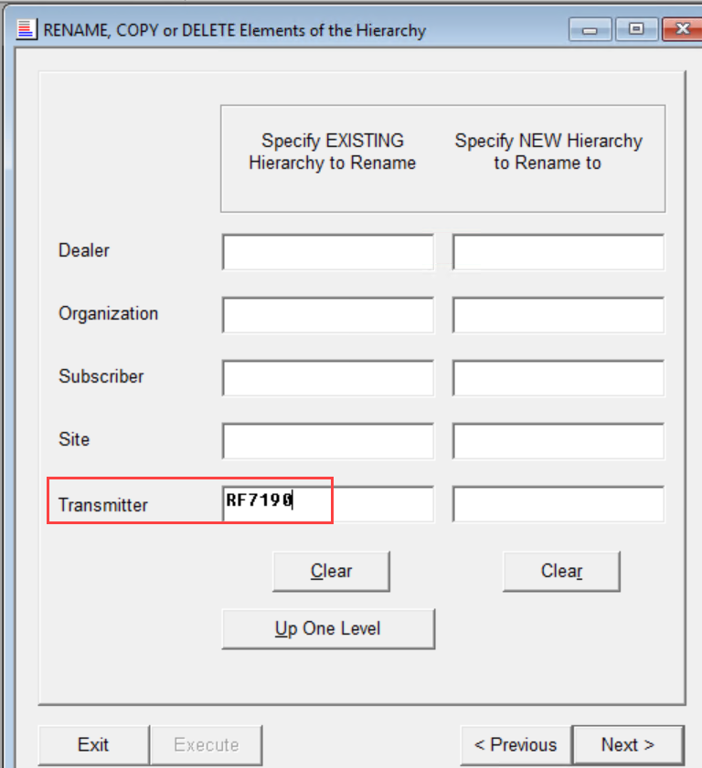
- Redefine Levels by using the Up One Level button to redefine the level as needed.
- Enter the New Hierarchy Fields with the appropriate values in the New Hierarchy Fields column and click Next once completed
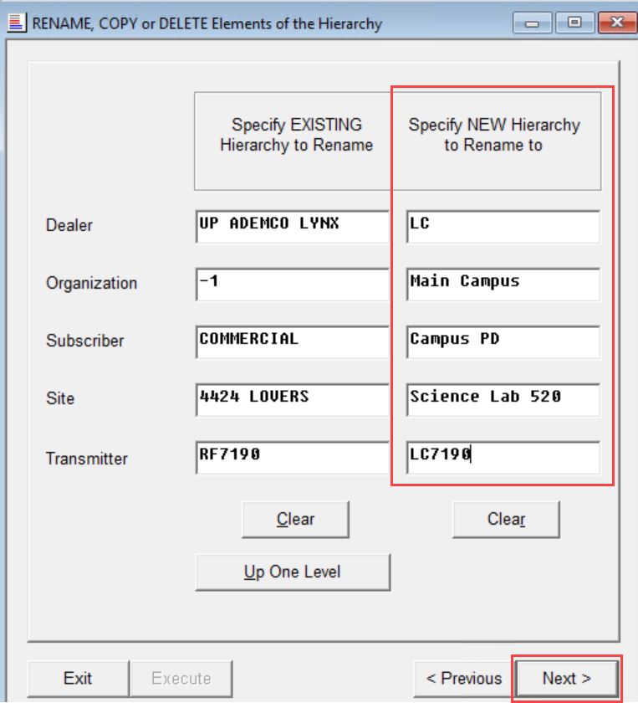
- Choose the appropriate table(s) that need to be changed or check the ALL tables check box to rename all tables in list.
- Click on either the Do NOT rename Signal History or the Rename Signal History radio button.
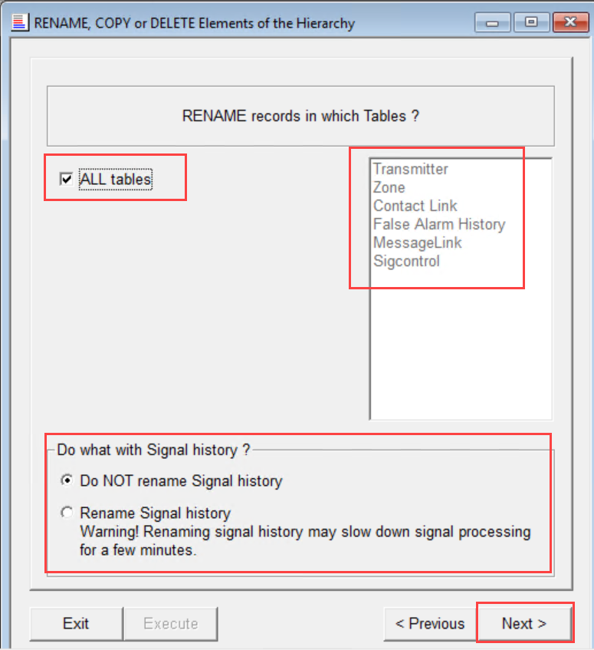
- Once all selected - Click Next
- In the Summary window, review the settings, and click Execute to make the changes in the database.
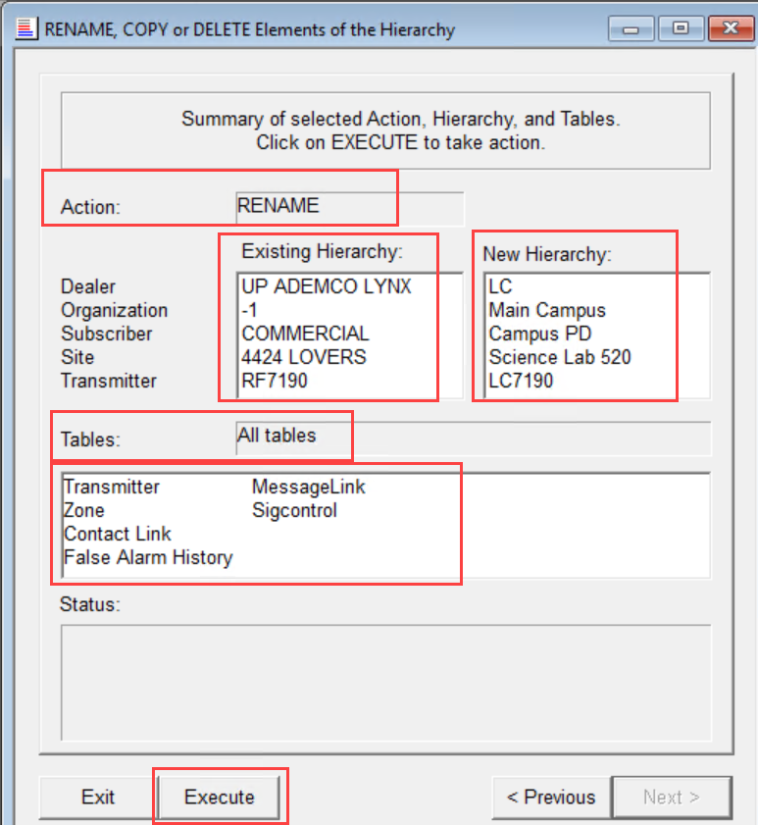
- Once the Status area shows “Request completed successfully”, Click on either the Exit button if done or the Next button if there is another hierarchy change needed.
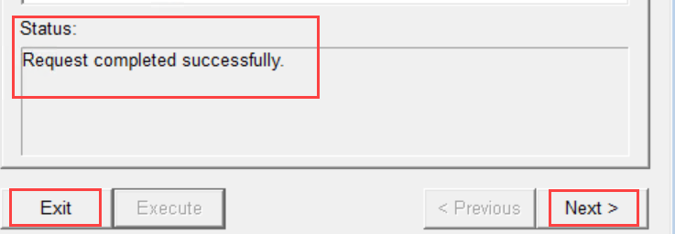
- Copy
Will copy (create new) records in all tables for a specified level in the hierarchy. For example, all records with Transmitter ID 'A' can be copied to new records with Transmitter ID 'B'.

- The copy function works the same as the Rename steps above. However, if the transmitter is being moved into a new hierarchy structure, that structure must be in the database.

Example: Transmitter A will be Copied as Transmitter B and the Site ID will also change. The new site id must also be in the database as well. So, if the Site does not exist, that site will need to be added prior to copying the transmitter(s) into that new site via Data Manager.
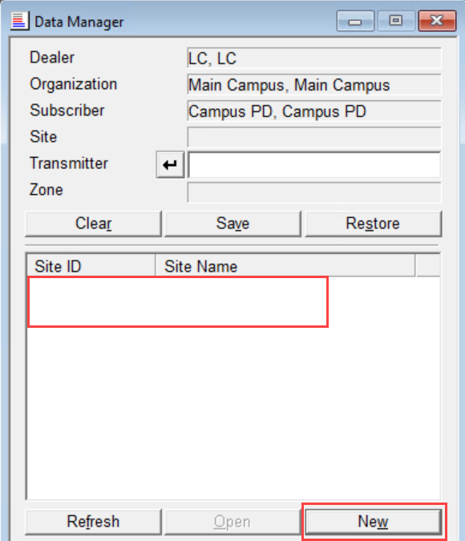
- Delete
Will delete records in all tables for a specified level in the hierarchy. For example, all records with Transmitter ID 'A' can be deleted.
- Select Delete from the main window and click next.
- Define the Records for deletion by typing the correct values or the Transmitter ID.
Once you exit the transmitter field, Phoenix auto-fills the higher levels. Use the Up One Level button to redefine as needed.
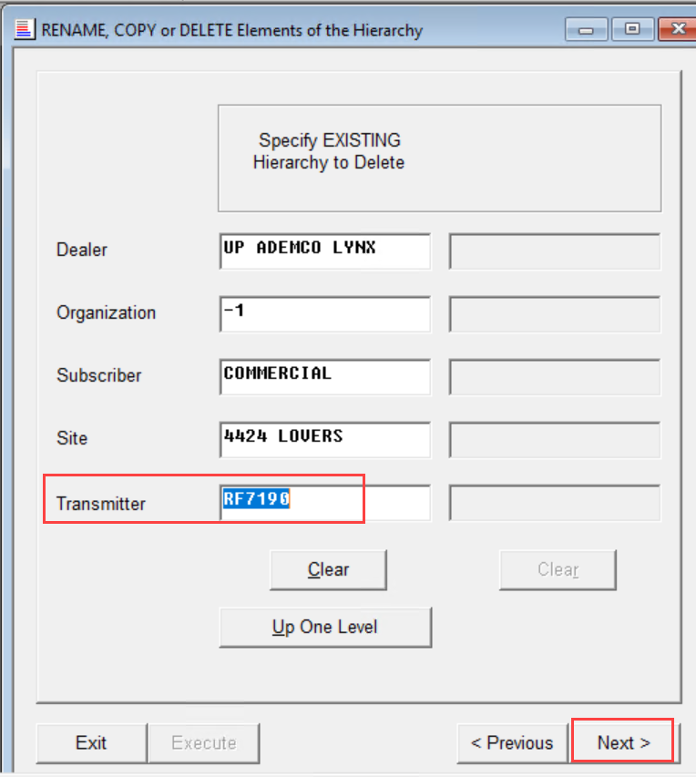
- Choose the Table(s) that are wanted to be deleted or check the ALL tables check box. Click on either Do NOT delete Signal History or the Delete Signal History radio button - Click Next
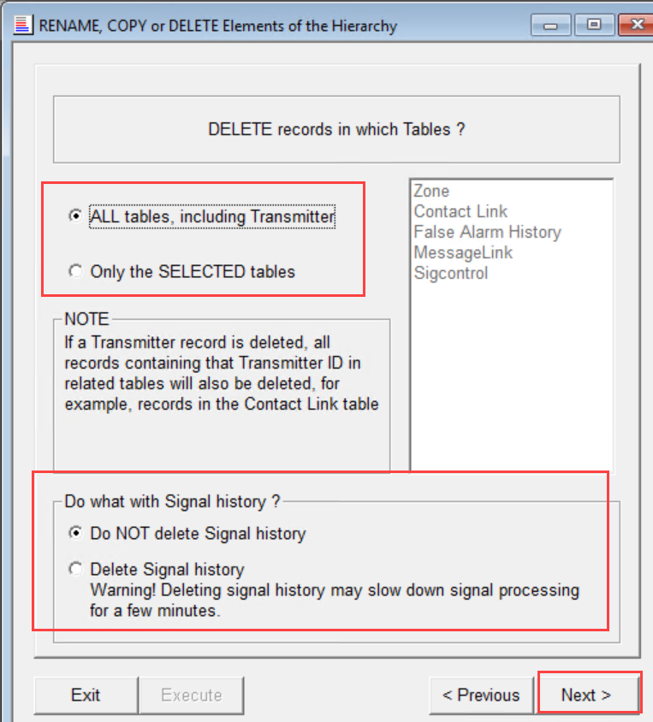
- Summary Window will open and can review the settings and what tables will be deleted. Once verified – click on Execute to make the changes to the database.
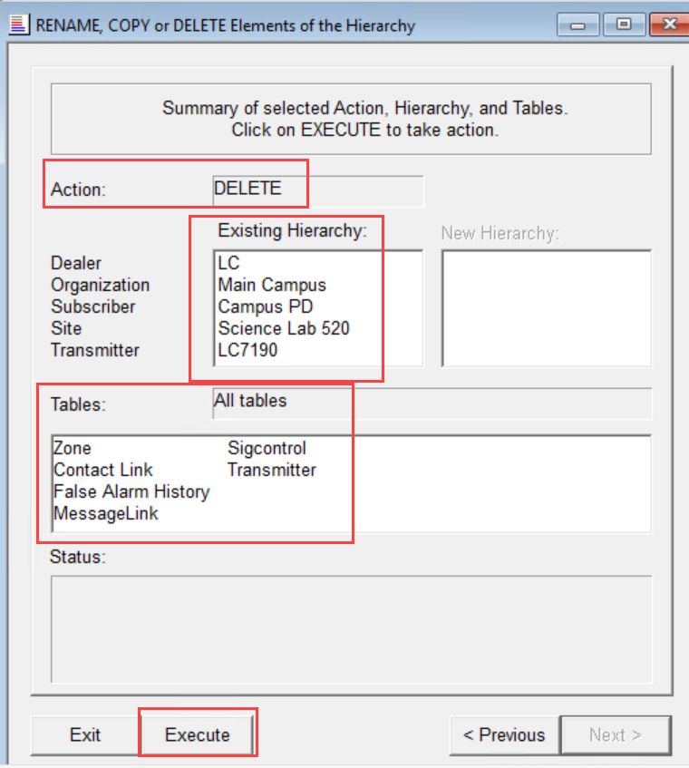
- Once the Status area shows “Request completed successfully”, Click on either the Exit button if done or the Next button if there is another hierarchy change needed.

