119110

How to Find List of Transmitters Entered into the System Using Data Entry

There will be times a list of transmitters is needed. This document goes over how to get that list using Data Entry. These steps can be used for any version of Phoenix.

Overview

When performing the steps below, the document assumes the user has the correct permissions to do so.

Steps:

1. Log into Data Entry using your login
2. Click on Tables – Transmitter

1. When the Transmitter form opens – Click on the Binoculars

***\*\* IF the error message below pops up, then other fields will need to be used to bring the number of rows below 5000***

1. Once the data populates in the form – should see the default account with all “-1” in the fields – Click on List View button

1. The List View will open. Can move the columns around by dragging and dropping where needed – Then click on the Print Preview Button

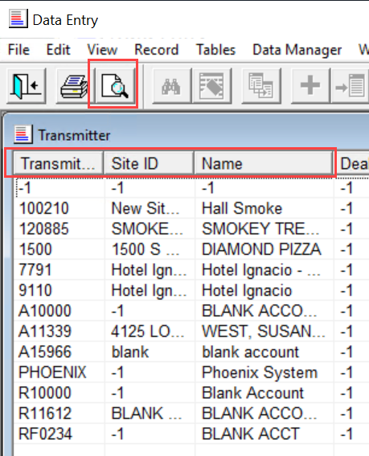

1. When the Print Preview opens – Click on the Print Preview Button to select the columns to print

1. In the Print Options window:
2. Rows & Columns Tab – Can select how many rows and columns want to display by selecting how to show the columns

1. Format Tab – Can select how to display the data

1. Font Tab – Can select the type of font wanted – Click OK button once done with all options

1. The Print Preview of how the data will display will show – Now can print or can open the html file in the directory shown and then print if needed

