114247

How to Add a SigCat Record in Phoenix
SigCat stands for Signal Category. Sigcat records define system-generated signals, such as late-open, early-open, fail-to-close, redundant fail, or any other signals that is deemed import type signals. These SigCats are used in conjunction with Sigtype and Sigcontrol records.

Overview
The Sigcat table helps defines system-generated signals and signals that require special attention from Phoenix. A Sigcat record is unique by the Sigcat ID field, however is recommended not to duplicate the SigCat descriptions.

Caution – Do not edit this table without talking to BoldGroup Technical Support.

There are predefined Sigcats that cannot be deleted: Sigcats
predefined by Phoenix are represented by numbers 1-5 and 50 and up. All other numbers can be used.

Below steps show how to enter a new Sigcat Record. These steps assume the user has the correct permissions to add these records.

Steps:
- Log into Data Entry
- Click on Tables – Click on Sigcat

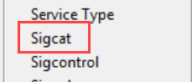
- Aft the Sigcat table form opens, verify what numbers are available to use by Clicking on the Binoculars
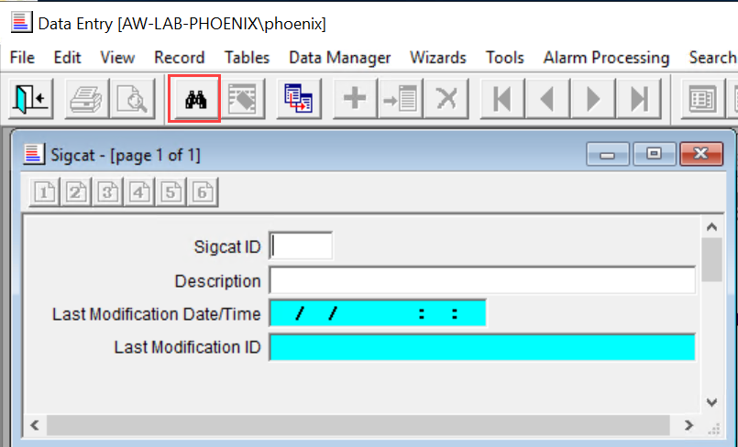

- Then click on List View button after the default record shows in window
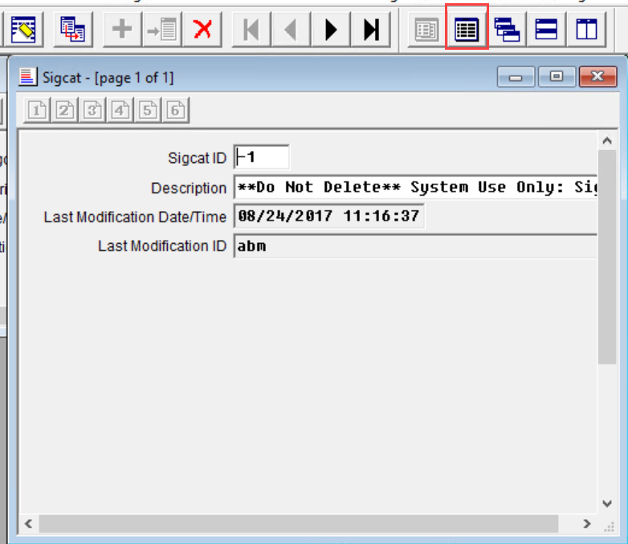
- Every customer will have a different list, except for the predefined. Find an open number to add the Sigcat needed
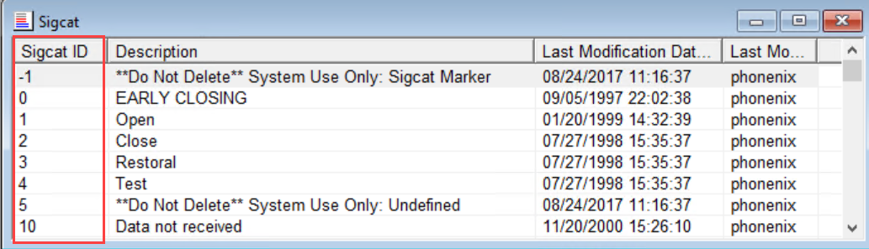
- Double click on one record to bring back to the main form – Click on Erase button to clear record

- Fill in the Sigcat ID that can be used and the Description – Click the Green + to add the new record
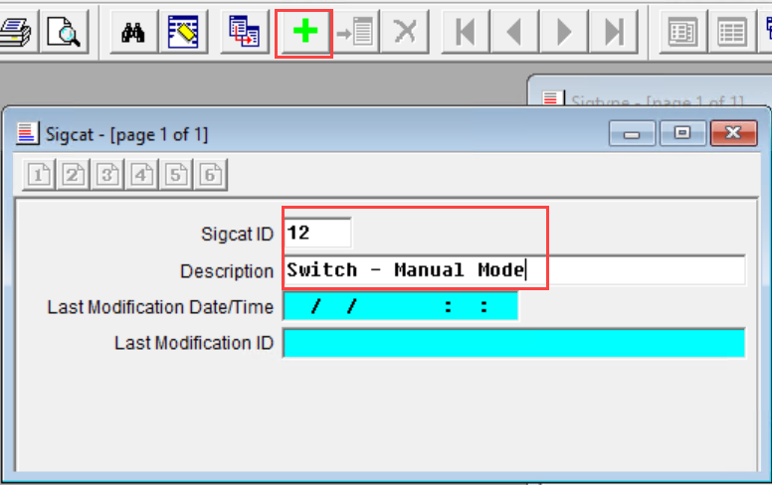
- The new Sigcat can now be used in the SigControl and SigType records
