120838

How to Add a New Transmitter
When a new panel to put online that information will need to be added to the Phoenix Software. This document goes over how to add easily using Data Entry and Data Manager.

Overview
The steps below assume the user has the proper permissions to add the data needed.

Steps:
- Open Data Manager in Data Entry
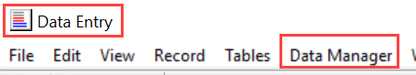
- Type in 0622 in the Transmitter field – Click on Arrow Key
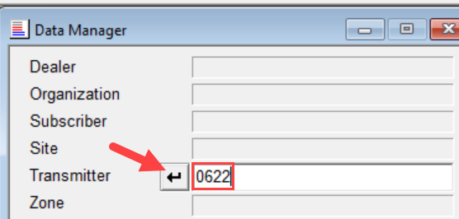

- If nothing comes back – then Select the hierarchy the transmitter is to be until Transmitter – then click on New button
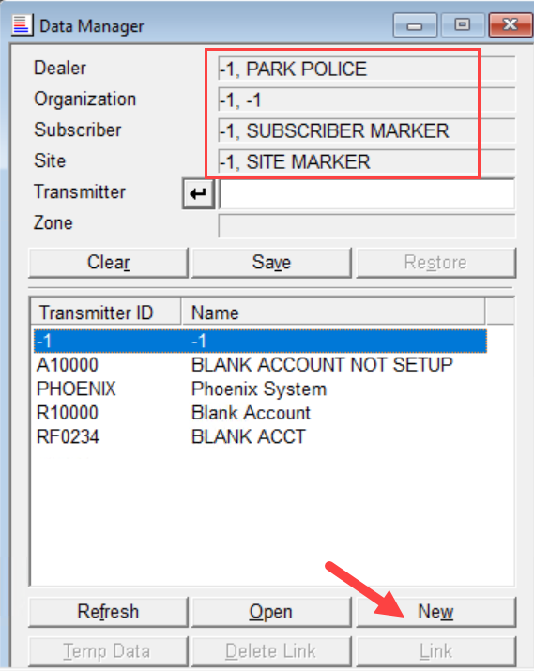

- Type 0622 in the transmitter id and fill in Name then click on Green + to add the record
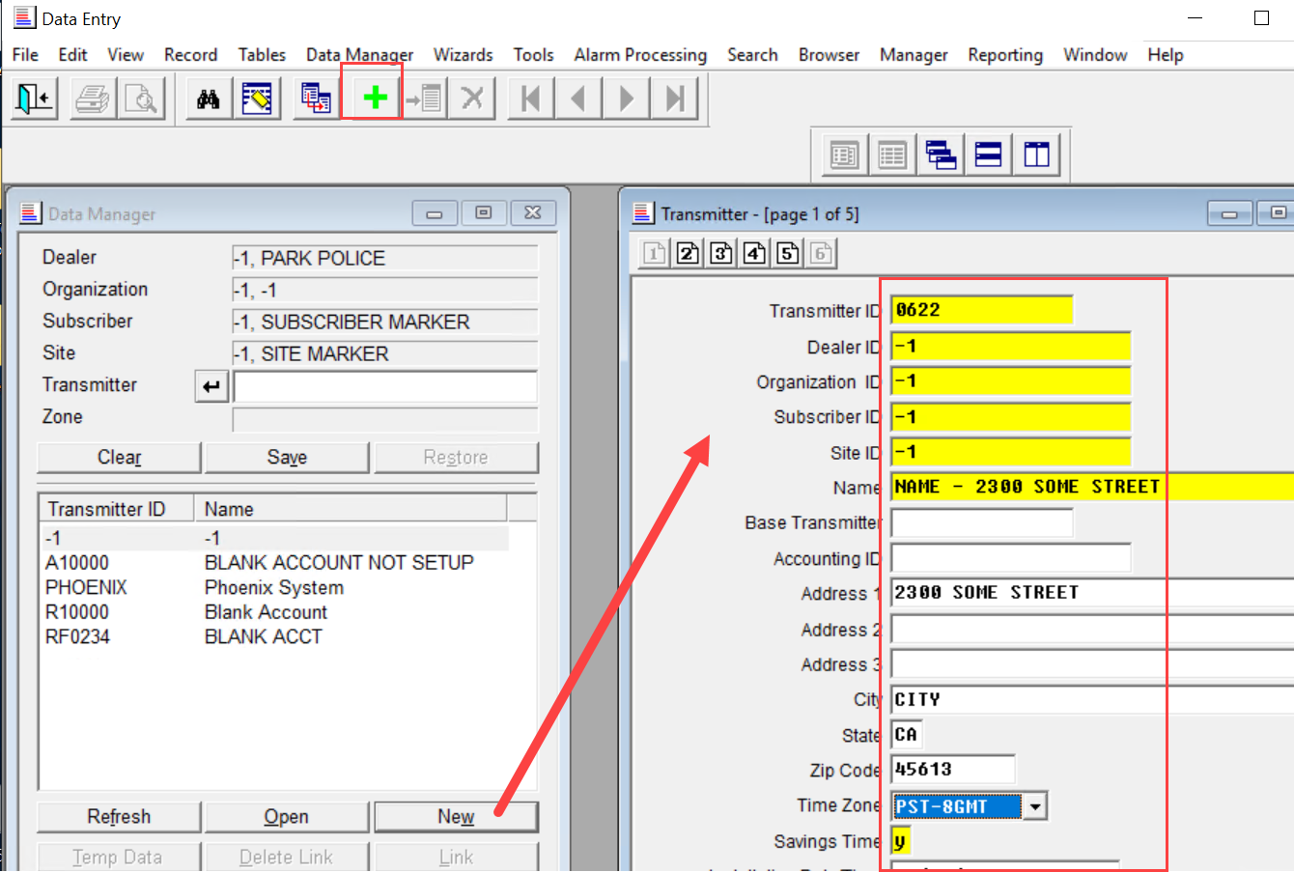
- Now the transmitter will show in the Transmitter window as being available. Will need to add the zones associated with that transmitter by double clicking on the transmitter – Click on New in the Zone to add the zones
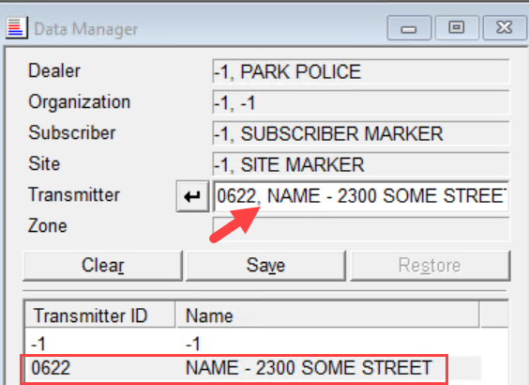
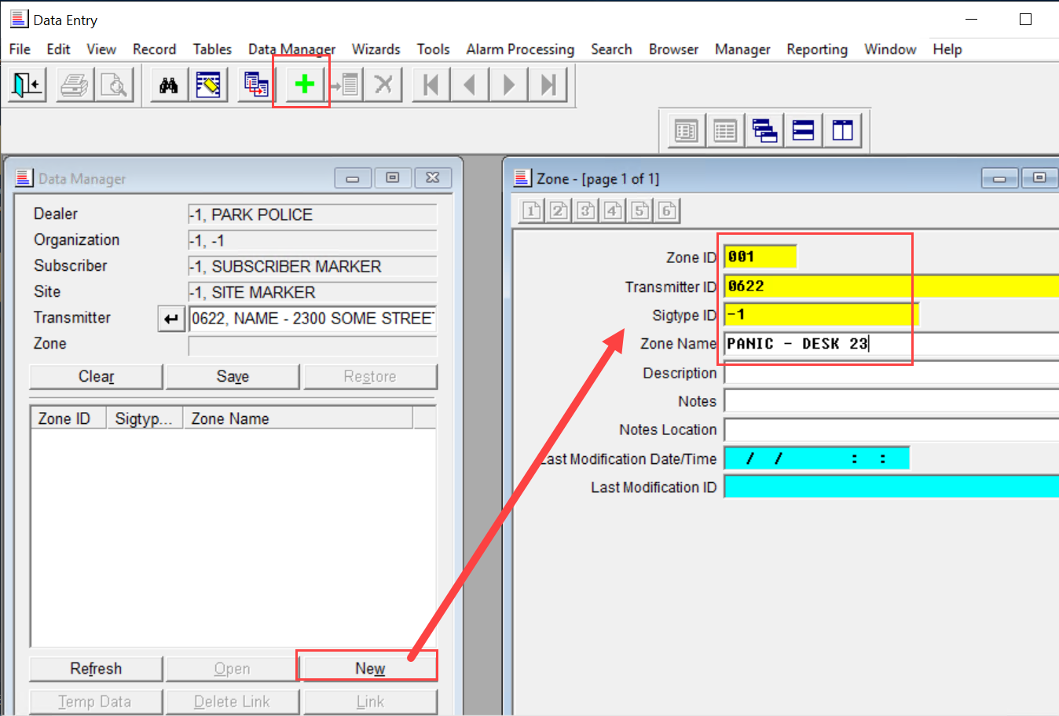
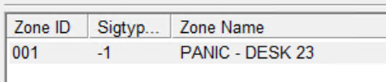
- Can continue to add zones by changing the Zone ID and Zone Name then click on the Green Plus to add the new record. As the zones are added they will display in the Zone area

