118594

How to Add a New SigType and SigControl Record into Phoenix
Sigcontrol (signal control) records tell Phoenix how to interpret and manage specific signals. The user will define the actions Phoenix takes when it receives these signals by setting up Sigcontrol records.

There are five different types of special signal processing that can define the Sigcontrol table: Convert, Delay, Redundant, Rwait (Restoral Wait) and Test. Each of these Control Types requires entries in different fields to work correctly.

There is a sixth Type listed in the dropdown list, No Action. No Action prevents the generation of Events; these types must use the No Action Wizard to create No Action Records.

SigType (signal type) are common names for signals or groups of signals. Signals coming from different receivers may have many different formats. Even though the signals have different formats, many signals share the same characteristics.
For example an E130, 11BO, and NBA may all be burglary signals. It is much easier to understand Burglary on the Alarm Processing screen and on reports, rather than E130, a, or b. The Sigtype table holds the names of the unique signal types received with one or two meaningful words (to set up the actual conversion of “E130” to “Burglary”.

For this document, it will go over how to enter a SigType record and a Convert Control Type record. These steps assume the user following them has the correct permissions to do so.

Overview
For each of the Control Types, a decision of which level of the hierarchy is
appropriate to hang the record will need to be made. It works on the principle of Relational Inheritance. If the Sigcontrol record applies to everything, system-wide, then it can be entered in once by hanging it at the system level by entering the marker value (-1) in every hierarchy field.

For example: if all E130 signals, for the entire system is to be converted to Burglary enter the marker record value (-1) in the Dealer Id through Zone Id fields. If the Sigcontrol record is different for each Site hang one on each Site by entering actual data in the Site ID field, and use the marker record value (-1) in Transmitter Id and Zone Id fields. If the Sigcontrol record applies to one Zone, enter actual values in the hierarchy fields including the Zone Id field.

The Convert Type is used to convert a signal, a zone, a transmitter, or a line card. To convert an incoming signal to a Sigtype already defined in the Sigtypes Table. The top fields of the Sigcontrol record define the “Convert from” values and the “Pseudo” fields define in the “convert to” values.
Helpful Hint – It is generally easier to enter Sigtype records first, but you can add one in the middle of creating a Sigcontrol record by simply opening the Sigtype table also.

Steps:
- Creating Sigtypes
- Make a list of all signals that is received and group them by type
- Determine what unique signal types are needed in Phoenix.
Example: burglary, fire, medical, low temperature, etc.
- Log into Data Entry – Click on Tables – Click on Sigtype
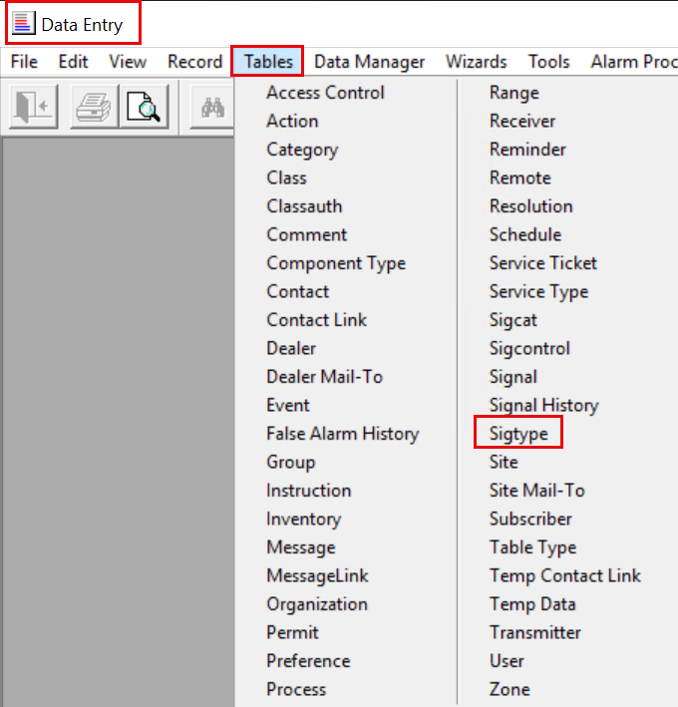
- Search Phoenix Sigtype to verify the type(s) needed that do not already exist
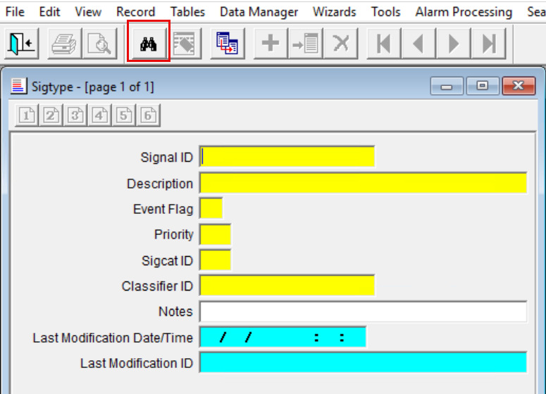
- Clear form to add new Sigtype
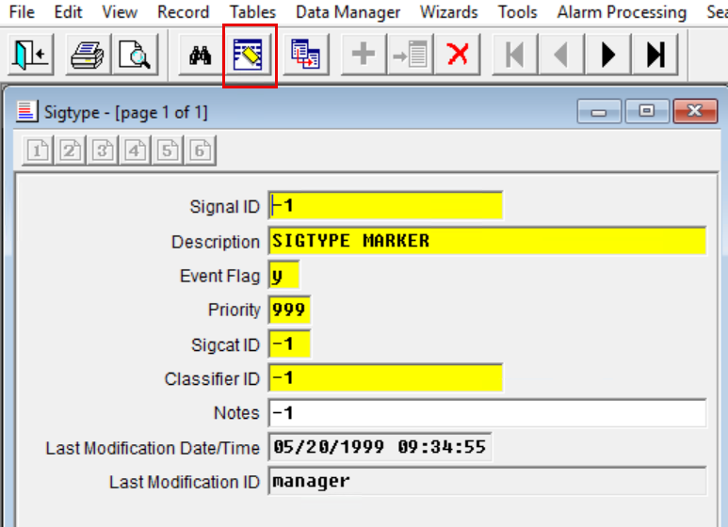
- Enter the following fields:
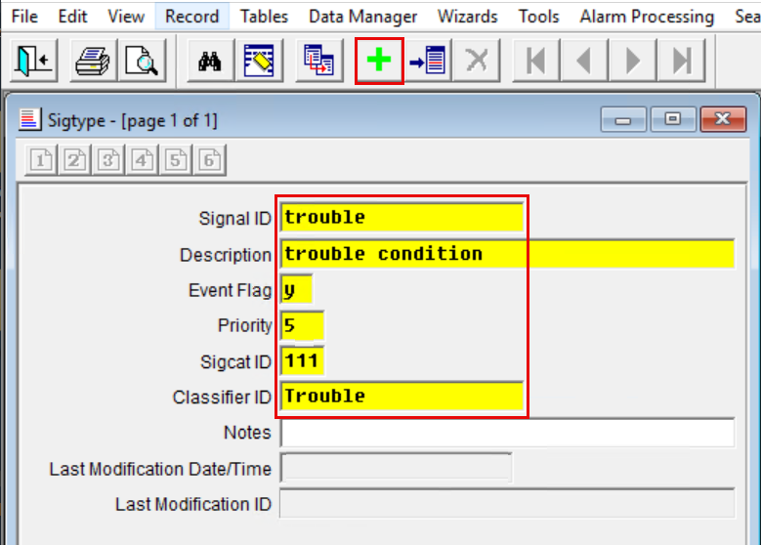
  - Signal ID field – Enter a unique, meaningful, descriptive word (or short phrase) that names the signal or group of signals. This field displays in Alarm Processing.
  - Description field – Enter a more detailed description of the signal type, this field displays in Alarm Processing.
  - Event Flag field – Choose y for yes, if the Sigtype should create an Event and n if it should not.
Caution – If this field is set to n Phoenix does not present the signal for processing by an operator; the signal is logged in the Signal table.
  - Priority field – Enter the Priority level of the signal type in relation to other signal types. The lower the number, the more important the Sigtype and the sooner the Event is presented to an operator in Alarm Processing. 1 is top priority, 2 is next in importance, etc.

More than one Signal may have the same priority (see example below).
Phoenix always offers the highest Priority, oldest Events first. The telephone icon that alerts operators of new Events on the Alarm Processing screen displays in different colors depending on the number in the Priority field of the primary signal’s Sigtype record. To take advantage of this feature assign the number in the Priority field as shown; the colors are hardcoded and cannot be changed.
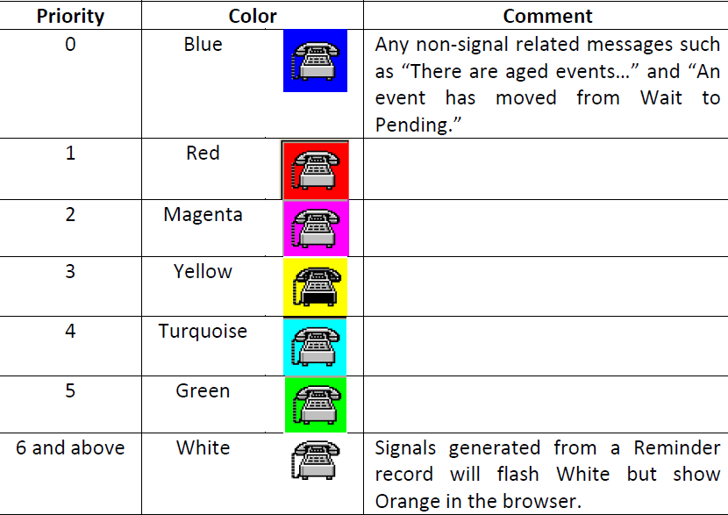
  - Sigcat ID field – Choose the Sigcat ID associated with the Sigtype from the dropdown list.
  - Classifier ID field – Choose a Class from the dropdown list that fits the signal. This provides a means of grouping multiple signals under one label for reporting purposes; for example: you may want to create a Class Trouble and select this field for the Sigtype of all trouble signals. You can create additional classes as needed by adding new records with type sigtype in the Class table
  - Notes field – Enter any additional comments or remarks concerning the Sigtype or the record.
  - Last Modification Date/Time field – Phoenix enters the date and time the record was last modified. The field is read-only and cannot be edited.
  - Last Modification ID field – Phoenix enters the Login ID of the user who last modified the record. This field is read-only and cannot be edited.
  - Click on the Add tool Green Plus – Phoenix writes the record to the Sigtypes table.

- Creating a Convert Type Sigcontrol Record:
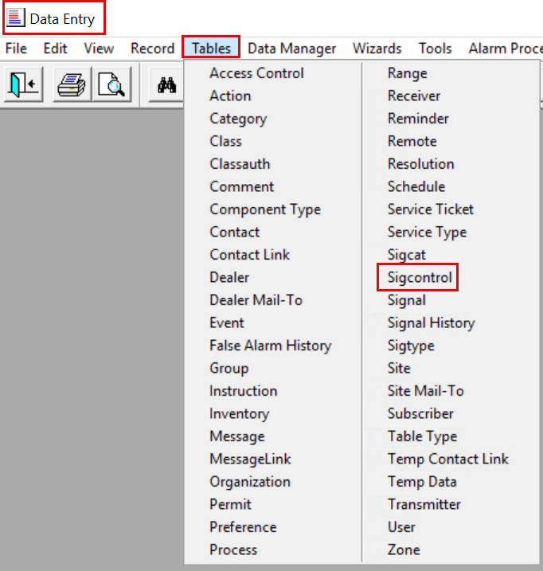
- In Data Entry – Click on Tables – Sigcontrol
- Identifier Field – will be filled in by Phoenix after adding the record
- Control Type – Select convert from the dropdown list
- If the signal conversion will be system level – Enter in the marker record (-1) in all hierarchy ids from dealer to zone
NOTE: If the conversion is specific to any of the levels, then that information will need to be added to that level id. Verify spelling is correct.
- Signal ID – Enter the Raw signal that is coming in to be converted, in this example NTA
- Packet Type ID – Enter the Marker Record value (-1), in most cases. If the same signal has two different meaning in your system you must enter a valid Packet Type from those listed in the Packet Type table.
Helpful Hint – Every time a signal is received, Phoenix writes the applicable Packet Type ID (based on the way the Collect parsed the signal) in the Packet Type Id field in the Transmitter record.
- Pseudo Transmitter ID – Enter the converted format of the Transmitter ID or leave blank if not converting a Transmitter ID.
- Pseudo Zone ID – Enter the converted format of the Zone ID, or leave blank if not converting a Zone ID.
- Sigtype field – Choose the converted format of the signal from the dropdown list or leave blank if not converting the signal. The list comes from the Signal ID field in the Sigtypes table.
- Last Modification Date/Time field – Phoenix enters the date and time the record was last modified; this field is read-only and cannot be edited.
- Last Modification ID field – Phoenix enters the Log-in ID of the user who last modified the record; this field is read-only and cannot be edited.
- Click on the Add Green Plus tool – Phoenix writes the record to the Site table.
