

Manitou Workstation Installation

**Table of Contents**

ii

About This Guide 4

Initial Installation Steps 4

Updating the Manitou Workstation Files 5

Authorizing a Workstation in the Supervisor Workstation 6

Setting up a Workstation for 2.0 6

Bold Group | Manitou Workstation Installation

# About This Guide

This guide is a functional overview (living document) and provides conceptual and summary operational information. This guide does not define all fields within the application; the application provides some definitions while other field names are familiar terms to those in the security industry. The assumption is that the reader is familiar with central station automation systems, as well as web services technology and terminology.

# Initial Installation Steps

1. Move the ManitouClientSetup.exe to the client machine.
2. Right-click and “run as Administrator.” The Manitou Client Setup Wizard displays the following:

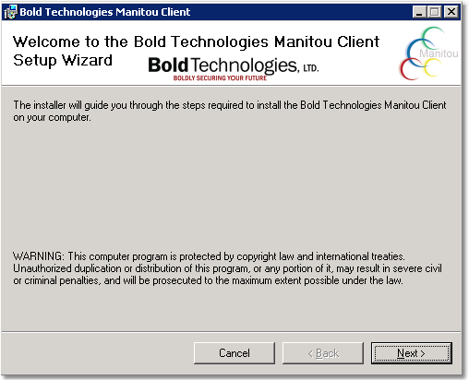

1. Click Next. The installer provides the following options for installation:

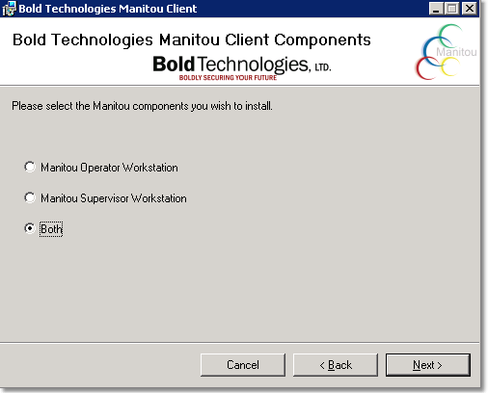

1. Select Both, to install both the Operator and Supervisor Workstation clients, then click Next.
2. The next window, may pop up behind the installer window, asks for the server name. Be sure to enter the server NAME not the IP address. This is most often the Distributer

machine name, typically Manitou 1 (primary/active). Enter the standby server in the Secondary server field. It is possible to enter up to two more standby servers in the additional two fields. Click Next.

1. Enter the Distributer server name into the Distributer field in the next window, then click Next.
2. Confirm the file path in the folder field is correct. Otherwise, click browse and specify a customer directory.
3. Select “everyone” to enable the Manitou Workstations for all users on this computer, then click Next.

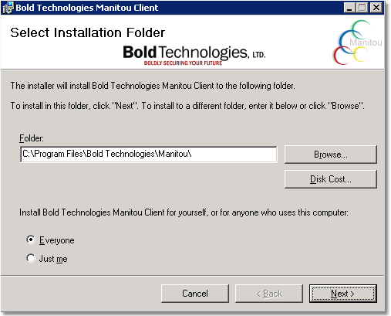

1. Click Next again to begin the installation. It is possible that an error message may display if the Sentry isn’t running. If you receive this message, click Yes.
2. When the client finishes its installation, the installer displays the completion message.

# Updating the Manitou Workstation Files

The installed files require updating to the latest file versions to ensure they are current. The following steps detail how to send these files through the Distributor commander.

1. Load the Manitou Server housing the Distributer Commander. This is generally Manitou
   1. Then launch the Distributer Commander. If no workstations display:
      1. Navigate to Start and type services.msc
      2. Locate the Bold Distributer and right-click and Start it.
2. Click the Admin Menu, in the Distributer Commander, and select “Send a Package to a Client.”
3. Send packages 1, 2, and 9 to the workstation(s).
4. Right-click the workstation in the Distributer commander and select “Update to the Latest Patch.” If sending to multiple workstations at the same time, use the Commands menu and select “Update to Latest Patch (selected clients).”
5. Once all updates complete, the patch numbers and the update number display in the Distributer commander. Now, go to the newly installed workstation client machines again and right-click and select Run as Administrator. If you do not run this as Administrator, every subsequent login will have to be authorized individually. This will

fail initially with an error stating “Failed to Connect to Sentry.” This is because the workstation must be authorized through the Supervisor Workstation.

# Authorizing a Workstation in the Supervisor Workstation

The following steps detail how to authorize a new Workstation in the Manitou Supervisor Workstation.

1. Open an already authorized Supervisor Workstation. This can be on any machine.
2. Navigate to the Maintenance Menu then select Workstations. (Or click the icon with the stacked Workstations)
3. Locate the “green line” pending workstation that matches the workstation name you are seeking to authorize.

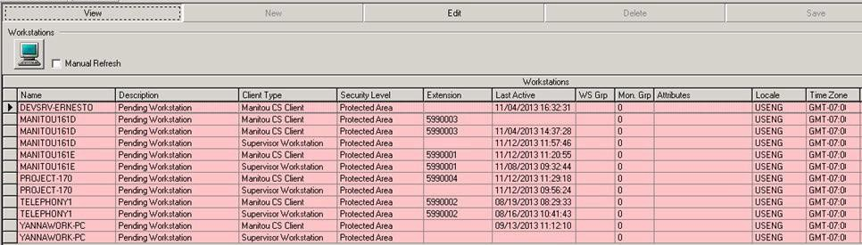

1. Click Edit and drop down the security level section, then change it from Pending to Protected Area. Then click Save.

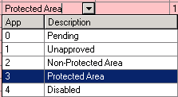

1. Re-attempt the login on the Workstation. This should now allow the workstation to login. Please note, each workstation (Operator and Supervisor) must be authorized individually.

# Setting up a Workstation for 2.0

ManitouNEO, 2.0, has installation requirements for the Web portion to work. Please note, even Web workstations, require authorization before they will allow access.

1. On the individual workstation(s), navigate to the Manitou directory, this is typically found under C:/Program Files (x86)/Bold Technologies/Manitou
2. Place the Manitou_Utility_Service_Setup.exe and place it on the workstation, then right- click and Run as Administrator.
3. Follow the prompts and complete the installation using the default values.
4. When complete, the Local Utility Service will automatically start running and is found under the services.msc. Open a Google Browser and load the Manitou Web interface URL provided to you. Test logging in. If you do run into the failure to connect to the Sentry, authorize the workstation, as you would all other clients, within the Supervisor Workstation